

**Unilever Pakistan Limited Khanewal**

**To Whom It May Concern:**

**<To2>**

**This to certify that Mr. <Name> S/O Mr. <fname> has working with us as <Designation> at Maintenance Department from <From2> to <To2>.**

**During his stay in Unilever Pakistan Limited, Tea Factory Khanewal his work and conduct remained very good.**

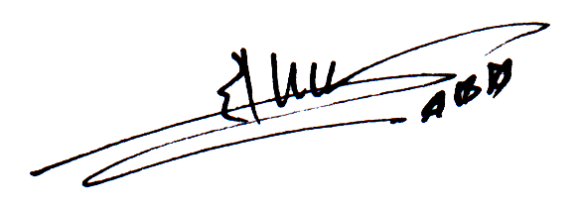

**Allah Diita**

**A. Human Resource Manager For Unilever Pakistan Limited**

**Factory Address:-** Unilever Pakistan Limited Tea Factory Chak # 88-A, 10/R Khanewal Phone # 0652556311 - 12, Fax 0652552482